[Insert your community name here] Community Emergency Plan

Plan last updated on: DD/MM/YYYY

How to use this template: This template is designed for you to fill in the details of your community emergency preparations. There are examples given to help you fill out the template. Detailed notes on how to create a plan by completing this template can be found in the Community Emergency Plan Toolkit document located in the Participant Activities and Worksheets folder as part of Module 6: Disaster Planning on the HHARP CD/USB drive.
If you are in immediate danger call 911

This document has been adapted for the Hawaii Hazards Awareness & Resilience Program from the Community Emergency Plan Toolkit, available at www.gov.uk.

This page intentionally left blank.

Plan Distribution List
The following individuals have a copy of the Community Emergency Plan:

Name | Role | Phone number/email address | Issued on
Ms. Epo | Administrator, County Civil Defense | 808 123-7890 | 01/01/2013
Miss Flood | Dam Safety Officer | floods@dlnr.gov | 02/02/13

Plan Amendment List
Changes and updates to the Community Emergency Plan are recorded here:

Date of amendment | Date for next revision | Details of changes made | Changed by
MM/DD/YY | MM/DD/YY | Annex X added | Community Emergency Coordinator
MM/DD/YY | MM/DD/YY | New Community Emergency Team members added | Community Emergency Coordinator
MM/DD/YY | MM/DD/YY | Updated volunteer details | Community Emergency Coordinator

This page intentionally left blank.

Table of Contents
Plan Distribution List i
Plan Amendment List i
Table of Contents iii
Description of Your Community 1
Local Risk Assessment 2
Local Skills and Resources Assessment 3
Key Locations 4
Emergency Contact List 5
Sample Telephone Tree 6
List of Community Organizations 7
Activation Triggers 7
First Steps in an Emergency 8
Community Emergency Group First Meeting Agenda 9
Actions Agreed Upon with Emergency Responders in the Event of an Evacuation 10
Alternative Communication Arrangements 10

This page intentionally left blank.

Description of Your Community

Local Risk Assessment
Risk assessment information collected in Module 5: Risk Assessment is summarized below:

Risks | Impact on community | What can the Community Emergency Planning Team do to prepare?
Example:  River through town can flood | - Flooding of local streets  - Blocked access to community center  - Damage to property | - Encourage residents to improve home flood defenses  - Work with local emergency responders to see if they can help with distribution of flood warnings and any evacuation and shelter establishment  - Find out what flood defenses exist or are planned in the area

Local Skills and Resources Assessment
The community skills and resources identified in Module 4: Community Resource Mapping are summarized here:

Skill/Resource | Who? | Contact details | Location | When might be unavailable?
Trained in first aid | Sandy Fortman | 808 789-6543 | 17 Brookvale Street | Can usually leave work within one hour
4x4 owner/driver | Bob Southwold | 808 468-0987 | Garages to rear of High Street | Tuesday mornings (already volunteers)
Chainsaw owner (tree surgeon) | Simon Chalmers | 808 325-7583 | Simon’s Landscaping – 4 Terrace Yard | Will need to travel from site
Water/food supplies | Grocery Shop | 808 345-2543 | 2 High Street | Shop closed on Weds but can call owner

Key Locations

Assembly Areas and Shelters Identified with Local Authority for Use as Places of Safety
Locations of safety (assembly/refuge areas or shelters) are listed here:

Building | Location | Potential use in an emergency | Contact details of key holder
Example: Church Hall | 1 Church Square | Assembly/refuge area | Colin Sato – Caretaker  808 234-9876
Watley Central; High School | Watley Street | Shelter | Jane Shulman – Vice Principal  808 456-7890

Emergency Contact List
The following individuals are contacted during an emergency:

Photo | Name: Paul Ridgeway
Photo | Title: Community Emergency Coordinator
Photo | 24hr telephone contact: 808 321-4567
Photo | Email: xx@xx.xx
Photo | Address: 2 Palm Road
Photo | Name
Photo | Title:
Photo | 24hr telephone contact:
Photo | Email:
Photo | Address:

Sample Telephone Tree
The phone tree works as a pyramid, with the coordinator at the top making the first call to two or more people. In turn, they call an assigned set of people and so on, until the tree is complete.

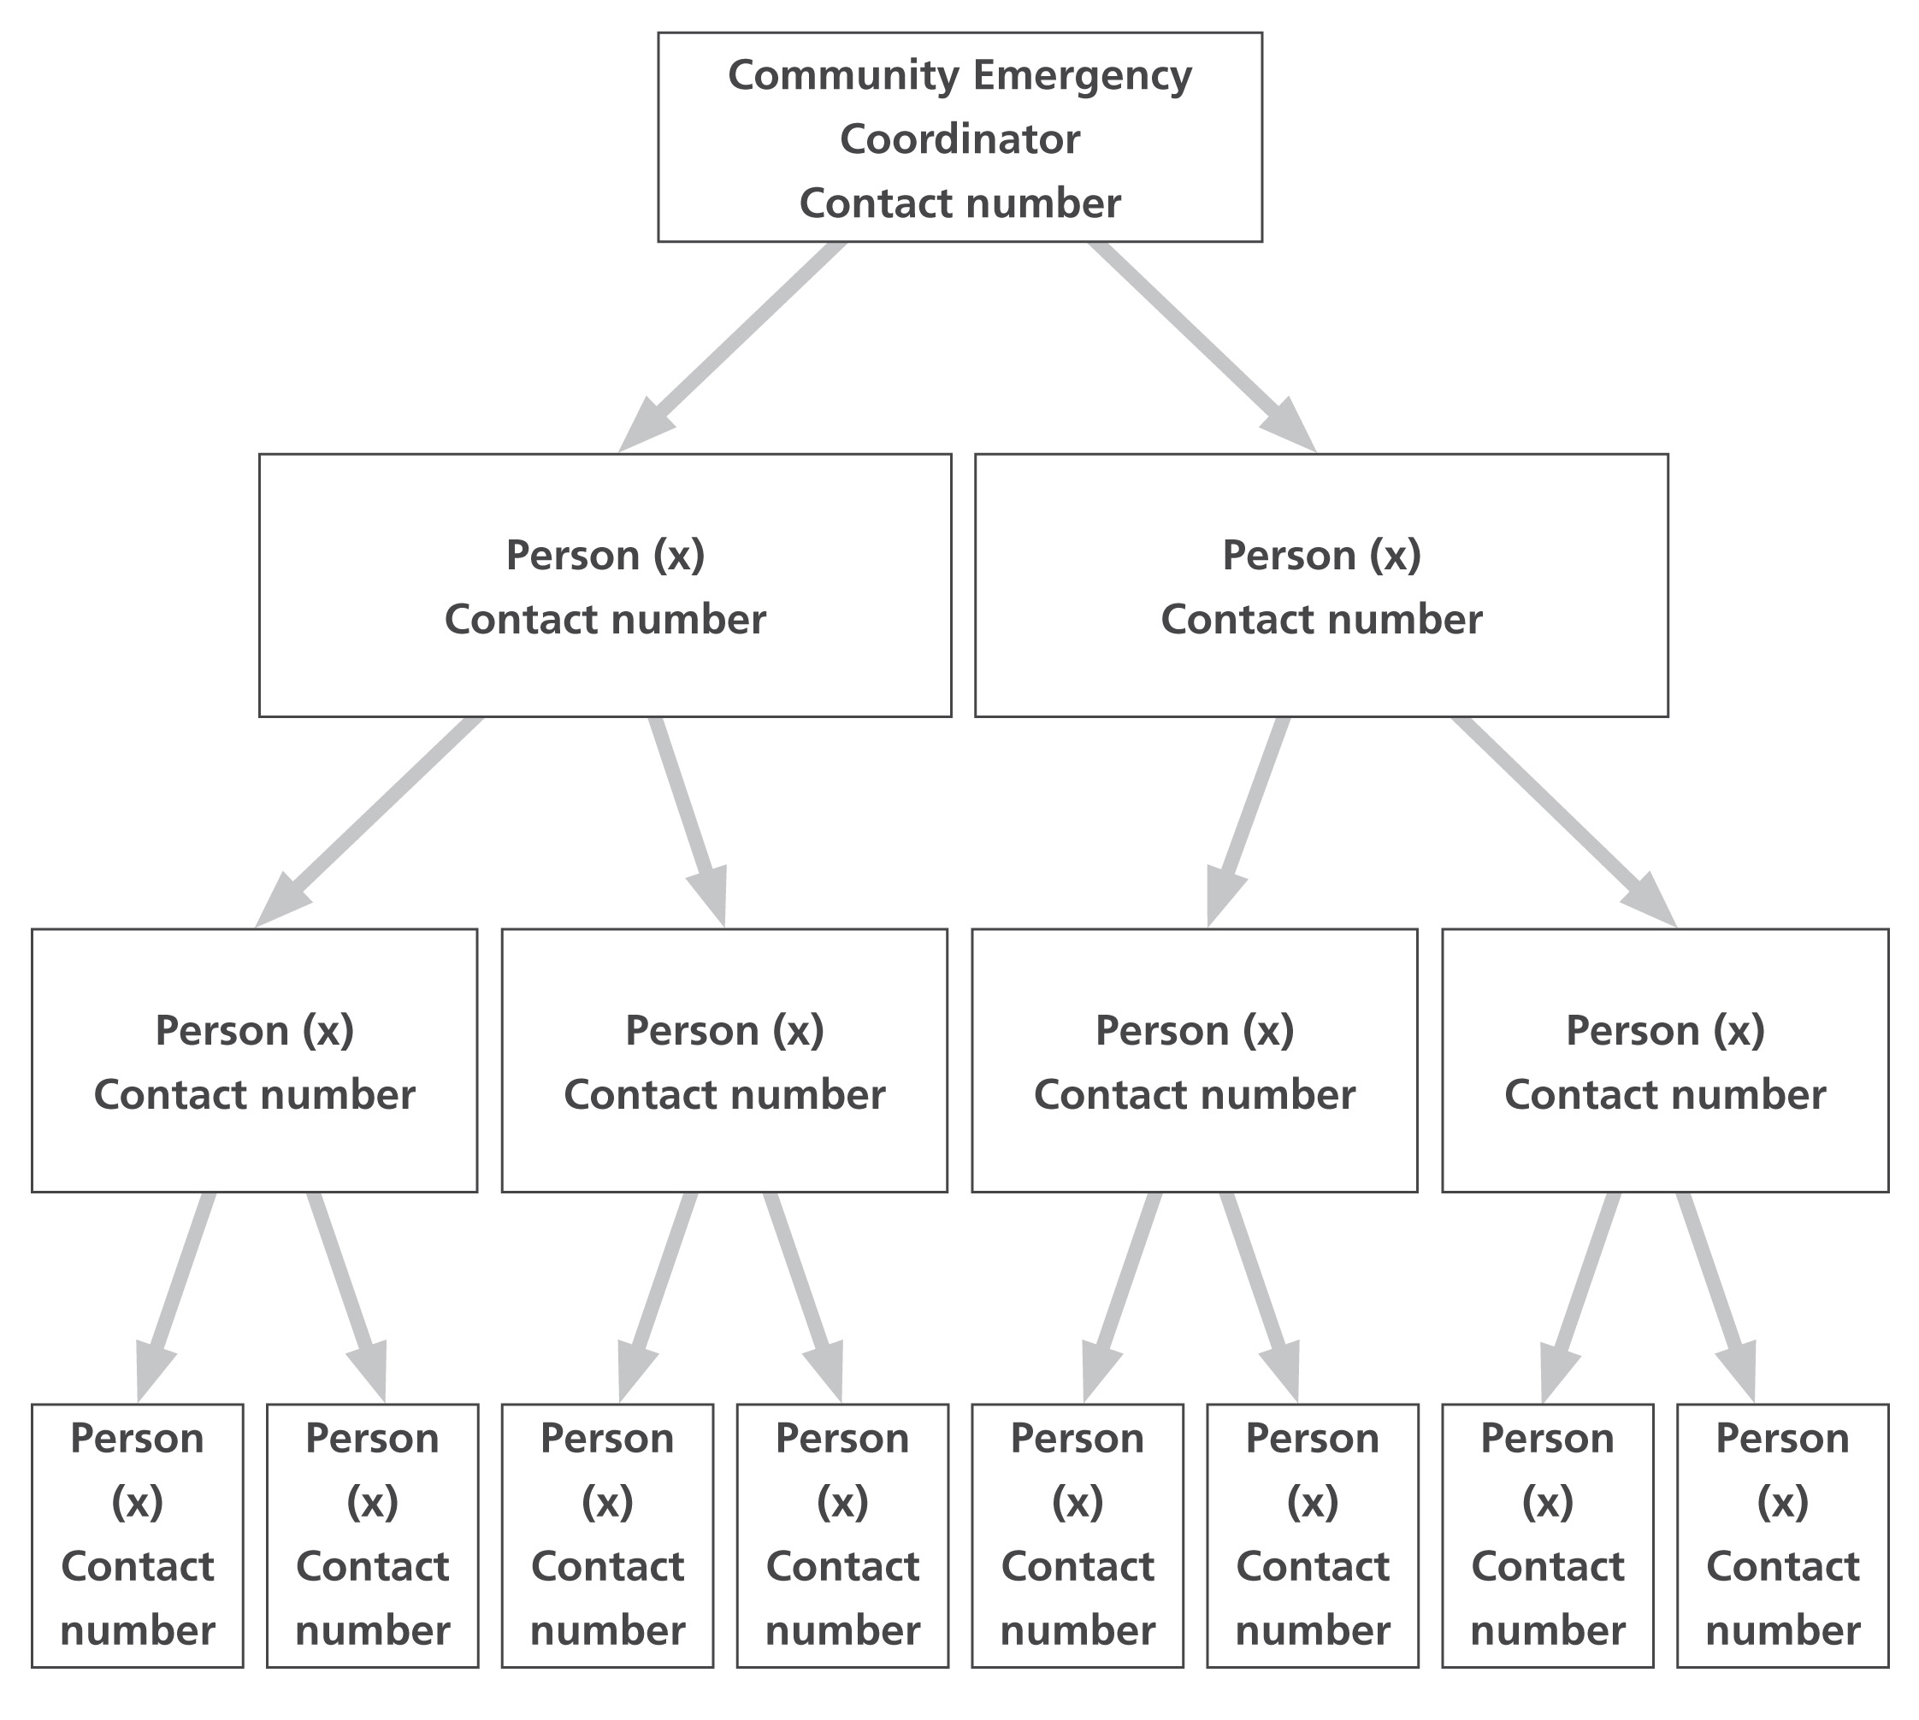

List of Community Organizations

That may be Helpful in Identifying Vulnerable People or Groups in an Emergency
Organization | Name and role of contact | Phone number
Anytown Care | Duty contact | 808 963-7541

Activation Triggers
This section describes the conditions or circumstances under which the plan will be activated.

- When a flood warning is issued.

- When a tsunami watch is issued.

- When County Civil Defense calls the community emergency coordinator.

First Steps in an Emergency
The following steps are followed once the Community Emergency Plan is activated:
Step | Instructions | Done  ☑
1 | Call 911 (unless already alerted).
2 | Ensure you are in no immediate danger.
3 | Contact the Community Emergency Group and meet to discuss the situation.
4
5
6
7
8
9
10
11
12

Community Emergency Group First Meeting Agenda
Date:
Time:
Location:
Attendees:
1. What is the current situation?
Location of the emergency. Is it near:
A school?
A vulnerable area?
A main access route?
Type of emergency:
Is there a threat to life?
Has electricity, gas or water been affected?
Are there any vulnerable people involved?
Elderly
Families with children
Other:
What resources do we need?
Food?
Off-road vehicles?
Blankets?
Shelter?
Other?
2. Established contact with the emergency services?
3. How can we support the emergency services?
4. What actions can safely be taken?
5. Who is going to take the lead for the agreed actions?
6. Any other issues?

Actions Agreed Upon with Emergency Responders in the Event of an Evacuation
Actions that you can take in your community to help your local authorities if an evacuation is necessary are listed here:

- Help police/local authority notify residents.

- Inform emergency responders about who might need extra help to evacuate.

Alternative Communication Arrangements

Staying in Contact if Normal Communications are Disrupted

Communication Type | Name of contact | Location
HAM Radio | Anytown Amateur Radio - John Springston | 22 Larch Drive

